**SELF POWERED AND SELF DRIVING ELECTRIC VEHICLE**

**Domain: Electric vehicle battery management, solar power harvesting, solar trackers.**

**Power calculations:**

Letting total mass of car with two people: 150 Kg.

Acceleration be 0.8 m/s^2

Force required to accelerate = 150*0.8 = 120 N

Coefficient of rolling friction be 0.018

Force required to overcome rolling friction=0.018*1500=27 N

Max speed of vehicle be 7m/s

Coefficient of air drag be 0.4

Air density in India 1.2

Frontal surface area of car be 1.8 m^2

Force required to overcome air drag= 0.5*0.4*1.2*1.8*7*7= 20 N (approximate)

Now,

Worst case power required to accelerate car from 0 to 7 and keep it running is = (120+27+20) * 7=1170 Watt (will never be required) as when car will be accelerating there will be no power required for air drag as its speed will increase gradually and when it will reach a constant speed no power will be required for accelerating the car which accounts for approx. 800 watts.

Therefore, a 1000Watt motor will be more than enough for our vehicle, most e-vehicles like e-rickshaw also run on 1000watt motor.

**Battery needed:**

Let us start with a 48V, 85A-h Lithium-ion battery.

range that it will give on full charge= (48*85) / (1000) = 80 Km

**specifications of solar panels:**

we need at least 4 panels of 340-Watt, size of each panel is 1.6 x 1.17 m^2

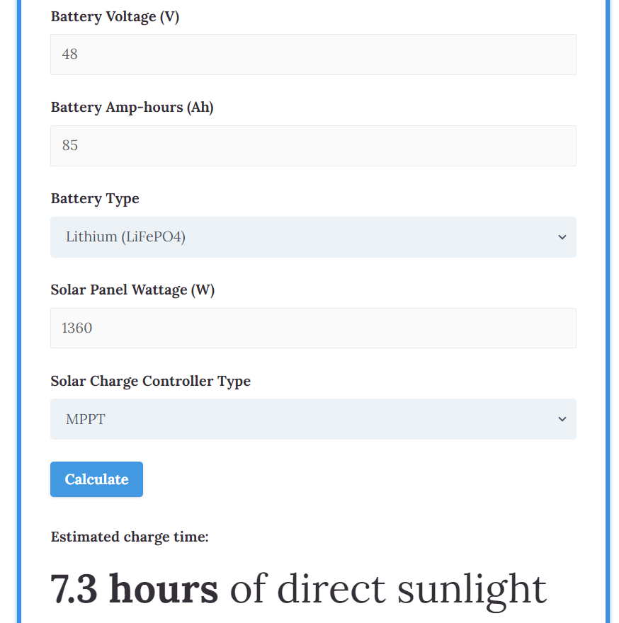

Therefore, from the above online charge time calculator we can see that:

4 panels of 340 watt with an MPPT solar charge controller and with continuous direct sunlight will charge our 48V,85ah battery in 7.3 hours.

**Solar tracker:**

It will be efficient to make a single axis solar tracker for solar power station. So that panels can follow sun from east to west while maintaining a fixed angle of 32 degree during winters and 2.3 degree during summers from horizontal for maximum light capture according to HYDERABAD LATITUDE.

This can increase the output of panels by 20-25 %

Things required are:

1 Arduino,2 Light dependent resistors (LDRs), 1 stepper motors, an axel fitted in panel frame, some gears and wires.

**Battery management system:**

According to above specifications here is a BMS for our e-vehicle

